Smart Music Controller
SP-PW7820

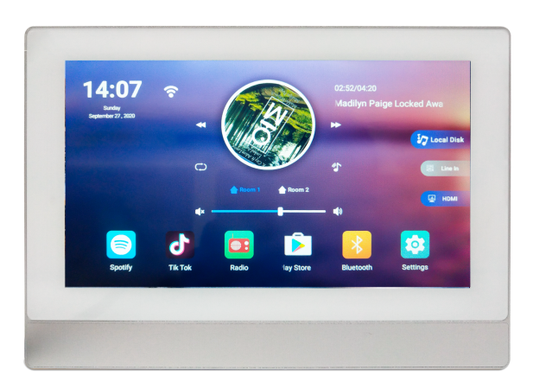
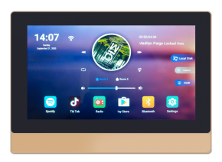

User Manual
To use the in-wall amplifier quickly and correctly, please read this user manual carefully and keep the it properly.
Note: The appearance and interface icons and pictures of the product are for reference only. Please refer to the actual product for details.
Web.: www.surpass-audio.com Email: info@surpass-audio.com

Ⅰ. Package Accessories
User Manual x 1 Inwall Mounting Box and Bracket x 1 set
Remote Control x 1 Screws 4 PCS

Ⅱ. Basic Parameters

Product | 7'' in-wall amplifier | Resolution | 1024*600 IPS
System | Android 8.1 | CPU | Quad core Cortex 1.5GHZ
RAM | 2GB | ROM | 16GB
Power Supply | AC110-250V | Output Power | 8*30W（MAX）
Output Impedance | 4-8 ohms | THD | 0.03%(1W,1KHZ）
Frequency Response | 20Hz-20KHz | Audio S/N Ratio | 98dB
Remote Control | Support | Wi-Fi | Support
Wire Box | 110*175*59MM | Product Size | 129*184.6*10.5MM
Ⅲ. Product Introduction
AC Power
Supply wire
RS485,
Audio Input

HDMI Output

8 Channels
Speaker Output

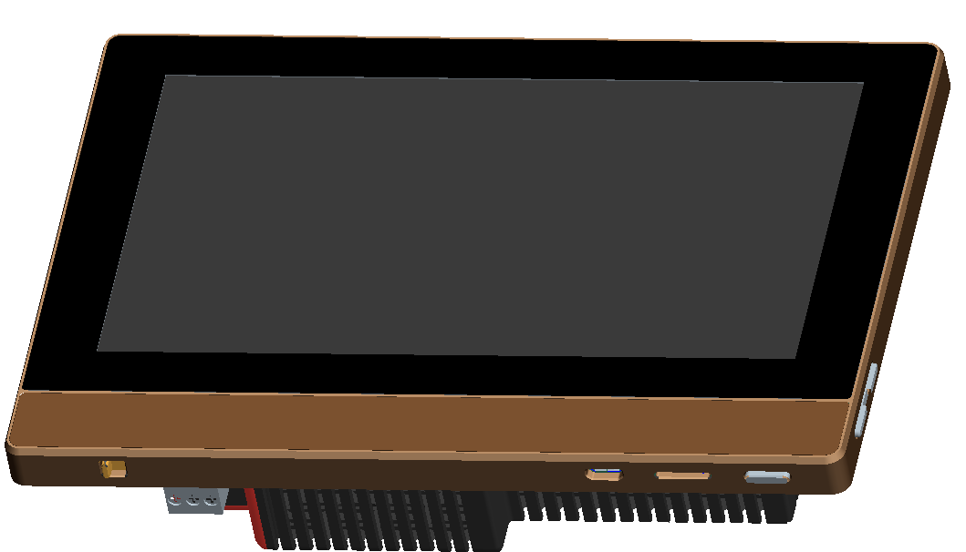
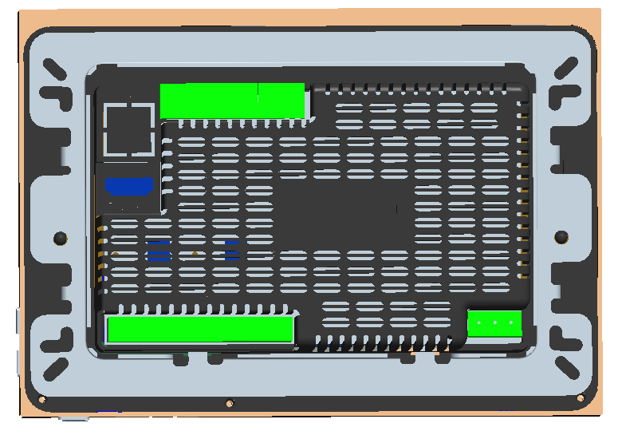

USB port

TF card port

On/off
Switch
Volume Key
Power
Switch

Ⅳ. External Interface Diagram
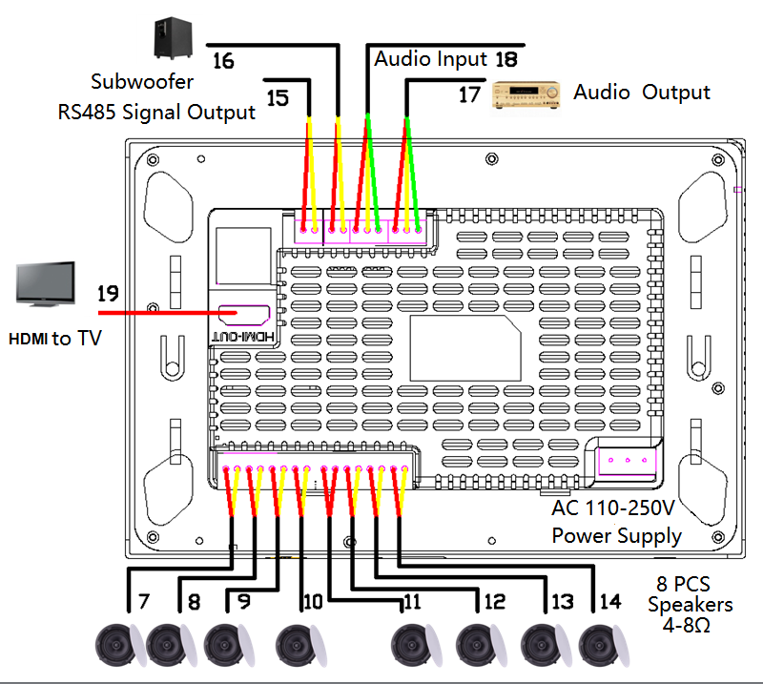
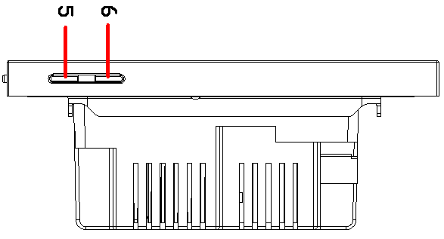
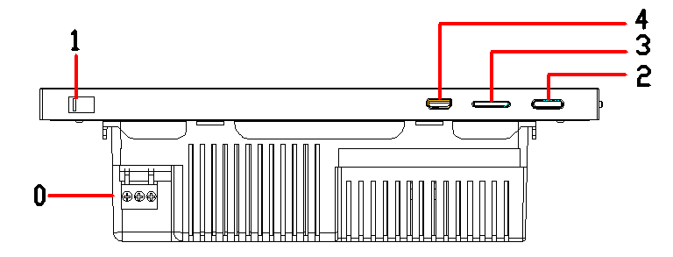

External interface description
0、Power Supply Terminal: Compatible AC90-250V power supply, power cable with two strands of copper core wire, single strand copper core over 0.75mm².
1、Power Switch: turn left to power ON and turn right to power OFF.
2、Switch: Long press to ON/OFF.
3、TF Card Port: support TF card up to 32GB
4、MICRO USB: OTG to USB disk up to 32GB
5、Volume Button: - (down)
6、Volume Button: + (up)
7/8/9/10/11/12/13/14、Speaker Terminals: SPK R + SPK R-: Eight Speakers: Speaker wire (200 cores). RVH2X100, RVH2X200, speaker power maximum 30W.
15、RS485 Terminal: Connect 485A+485B to control background music through external equipment. Other 485 devices can also be controlled by this audio wall amplifier panel. 485 interface (optional): 485 line, connected to 485A +485B+GND.
16、Active Subwoofer Terminal l: Connect GND+SW to connect an powered subwoofer.
17、Audio Output: use Audio wire (three core with shielded wire: commonly known as microphone wire, RVVP2X0.5、RVVP2X0.75, connect OUT R +OUT L+GND to connect an extra amplifier.
18、Audio Input: AUX L + AUX R + GND: Audio wire (three core with shielded wire: commonly known as microphone wire). RVVP2X0.5, RVVP2X0.75
19、HDMI Port: Connect to TV by HDMI cable.

Ⅴ. Remote Control Function Introduction
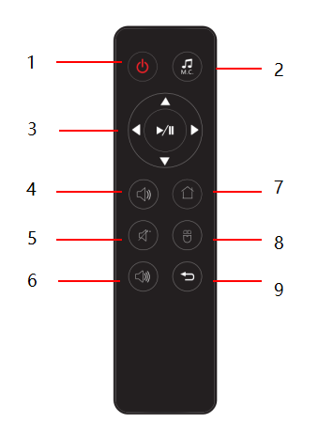
1.Power On/Off: “short press” to standby the screen, press again to turn on the screen; “long press” to shut down the audio wall amplifier panel, long press again to turn on the device.
2.Audio Source: press this button to switch audio source, you can switch the device audio source, AUX audio source.
3.Direction, OK/Play: Press to move the cursor up, down, left, and right to select options in the menu, and press the enter key to enter this key to switch between play and pause.
4.Volume Down: press to decrease the volume.
5.Mute button: press the button to turn off the device sound, press again to turn on the sound.
6.Volume Up: press to increase the volume.
7.Home: press to enter the main interface.
8.HDMI: press to turn on/off HDMI output.
9.Back: press in the sub menu to return to the previous menu.

Ⅵ. Installation Instructions

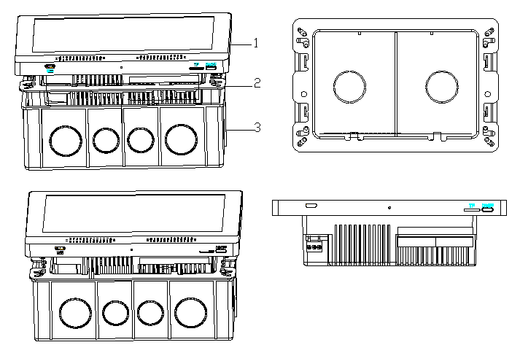
1. Pre-embed attached 175*110*60MM back cover. Back cover depth is 60mm.
2. Tighten the bracket with the bracket screw on the back cover.
3. Tighten the wire inside the back cover to the corresponding function terminal on the device. Then insert the terminal into the terminal post. Then put the device into the bracket and push down.
4. Wires used in this product: multi-strand copper wire, coaxial cable, audio cable, speaker cable.
5. Please consult the supplier when installing this machine. Do not repair the device without authorization. If you need to repair it, please consult the supplier and have it repaired by qualified personnel.

Picture 1: ①Audio Wall Amplifier Panel ②Mounting Bracket ③Mounting Box
Installation Steps: A. bury ③ into wall B. fix ② onto ③ by screws
C. hang ① into the bracket and push down.
Ⅶ. Main Interface Software Function Introduction

Reminder: Because of constantly updating functions and software, everything is subject to the device product introduction in your hands!
Ⅷ. Trouble Shooting
7.1 The device does not turn on
1》Whether the AC 110-250V power cord is connected properly.
2》Whether the AC 110-250V power switch is turned on (right to ON, left to OFF).
3》The power switch needs to be pressed for more than 3 seconds.
7.2 No Touch
1》Whether there is water or dirt on the screen (clean up the water or dirt).
2》Whether there is water or oil on hands during operation.
3》Whether there is high-power machine interference next to this device.
7.3 No sound from the speaker
1》Whether the speaker wire is connected properly, and whether the wires are touched together.
2》Whether the device is muted.
3》Whether the volume of the device “amplifier 1 / amplifier 2” is turned on too low, and whether the total volume is turned off.
4》Whether the sound source of the device is switched to another sound source state (when playing, whether the sound source is switched to a Bluetooth sound source or AUX sound source).
7.4 No sound or the sound is too low when playing Music
1》Whether the phone sound is not turned on.
2》Whether the volume of the power amplifier of the device is turned on (adjusting the volume has no effect on the Bluetooth volume, you need to adjust the volume of the power amplifier of the audio interface).
3》Whether the distance between the mobile phone and the device is too far, causing the Bluetooth disconnection between the mobile phone and the device.
7.5 No sound or the sound is too low when playing AUX
1》Is the AUX audio cable not properly connected?
2》Whether the volume of the power amplifier of the host is turned on (adjusting the volume of the host has no effect on the AUX volume, you need to adjust the volume of the power amplifier of the sound effect interface)
1》Whether the AUX audio cable is properly connected.
2》Whether the volume of the power amplifier of the device is turned on (adjusting the volume of the host has no effect on the AUX volume, you need to adjust the volume of the power amplifier of the sound effect interface).
7.6 No network
1》Is the WIFI signal too bad?
2》Whether the WIFI signal is disconnected
7.7 Can't wake up
1》Check if the voice wake-up assistant is turned off.
2》Try to bring the distance closer to eliminate the environmental noise factors.
3》Check whether there is debris on the sound pickup hole on the surface of the device, which is blocked.
GUANGZHOU SURPASS AUDIO CO., LIMITED.
No.347 Tiannan Street,Tanshan,Hualong Town,Panyu,Guangzhou,China 511434
Web.: www.surpass-audio.com Email: info@surpass-audio.com

