
SP-ME500
Mixer Amplifier

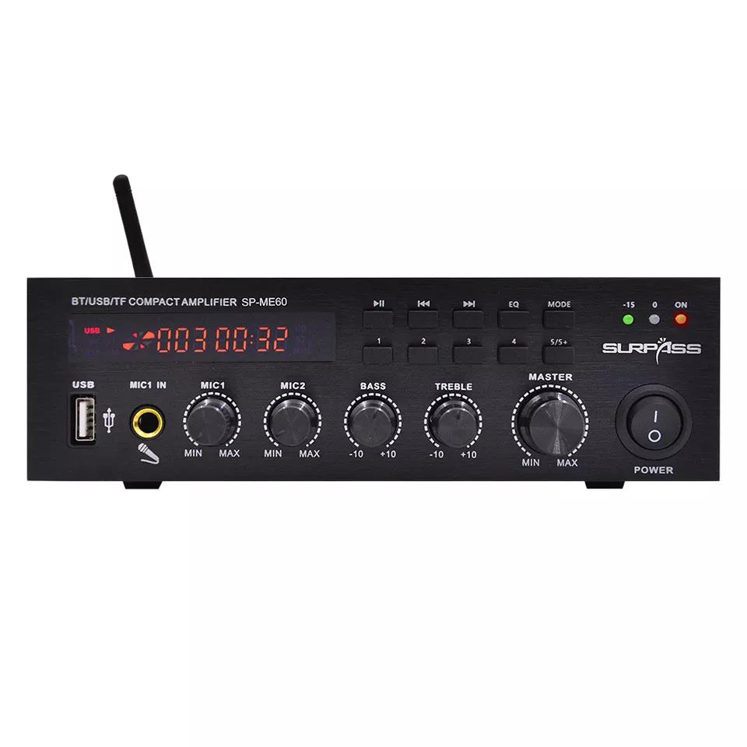

Features:
Line Input: AUX1, AUX2
Sensitivity: 330mV
Microphone input: MIC1 (priority), MIC2, MIC3
Sensitivity: 10mV
Output voltage: 100V/70V/4Ω-16Ω
Protection type: power-on delay, short circuit, over temperature, stepless fan acceleration
Indicators: Power, Signal, Clip, Protect
Input power: AC230V/50Hz
Iron Panel
Production Dimension: 483*320*89mm
Package Size: 550*380*150mm
Specifications:
Place of Origin | China
Brand Name | Surpass
Model Number | ME500
Warranty | 3months-1year
Customized | Yes
Line Input | AUX1, AUX2
Sensitivity | 330mV
Microphone input | MIC1 (priority), MIC2, MIC3
Output voltage | 100V/70V/4Ω-16Ω
Protection type | power-on delay, short circuit
Indicators | Power, Signal, Clip, Protect
Input power | AC230V/50Hz
Material | Iron Panel
Production Dimension | 483*320*89mm
Package Size | 550*380*150mm


Web: www.surpass-audio.com; Email: info@surpass-audio.com Page 1/1

