
SP-PW425E
Home Amplifier 4*25W
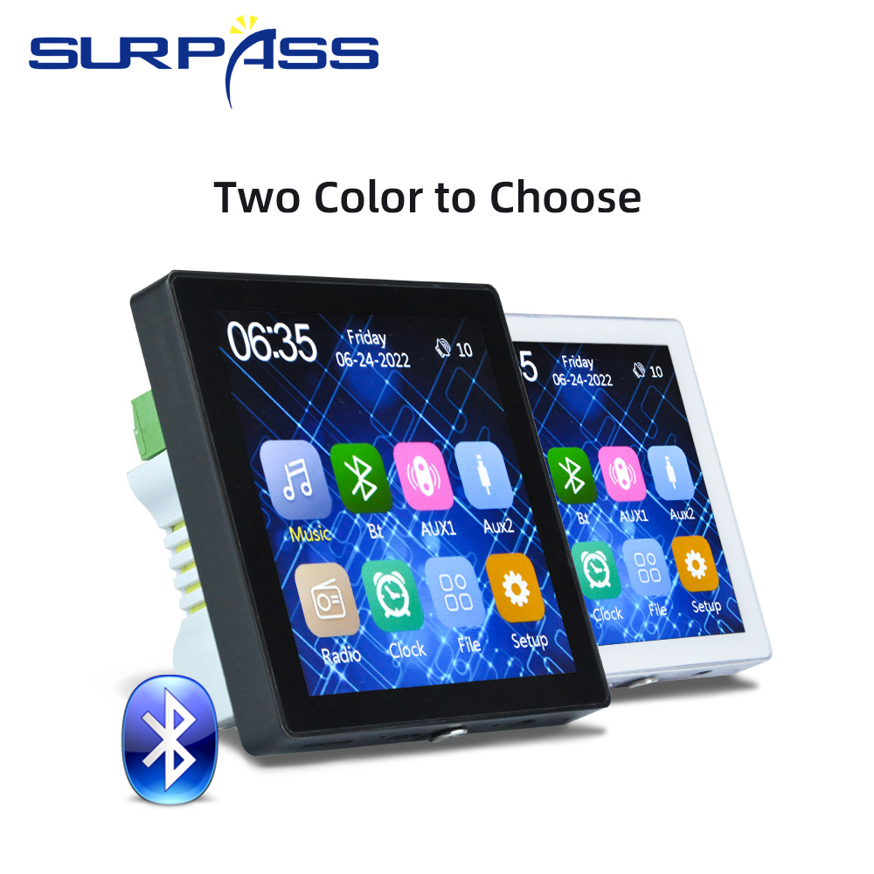

Features:
● Support English, French, German, Spain, Portugal, Italian, six languages
● Two way Bluetooth(received and send), can connect to bluetooth TV and bluetooth Ceiling speaker by Bluetooth
● Power: AC220V(50HZ) allow 110V-250V
● Output Power: 4*25W
● Main screen size: 4 inch HD screen
● Touch Screen
● Expand TF card memory: 32GB
● USB: Support OTG USB 2.0, 32G can be read
● Output impedance: 8Ω
● FM Frequency: 87.5Hz-108MHz
● Audio S/N ratio: ≥98db
● Bluetooth distance: 10m
● Infrared remote control distance: 10m
● Radio: Built-in all-digital auto-tuning radio, 30 radio stations
● Product size: 86*86*10mm

Specifications:
Model Number | PW425E
Type | Home Amplifier
Channels | 4
Place of Origin | China
Power | AC220V(50HZ) allow 110V-250V
Output Power | 4*25W
Main screen size | 4 inch HD screen
Expand TF card memory | 32GB
USB | Support OTG USB 2.0, 32G can be read
Output impedance | 8 Ohm
FM Frequency | 87.5Hz-108MHz
Audio S/N ratio | ≥98db
Blue-tooth distance | 10m
Product size | 86*86*10mm


Web: www.surpass-audio.com; Email: info@surpass-audio.com Page 1/1

